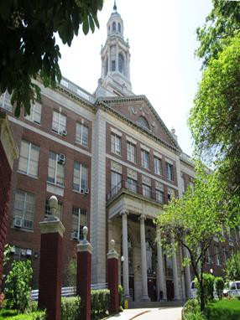

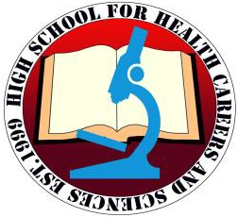
To Apply to High School for Health Careers, and Sciences:

High School
for Health Careers,
and Sciences

549 Audubon Avenue, 3rd Floor
New York, N.Y. 10040
212-927-1841
www.hshcs.nyc

On the application form, select High School for Health Careers, and Sciences using the school code: M33A

CTE – Certified Nursing Assistant program using school code: M45C
Idioma Dual / Dual Language Program: M33B

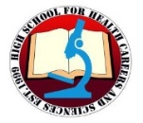

For more information, please contact us at:
549 Audubon Avenue, 3rd Floor New York, N.Y. 10040
Phone: 212-927-1841 ext. 6336
Email: jsantana@schools.nyc.gov
Joanny Santana, Guidance Counselor
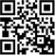

Elsa Roman, Parent Coordinator

Javier Trejo, Principal
(929) 333 - 4289

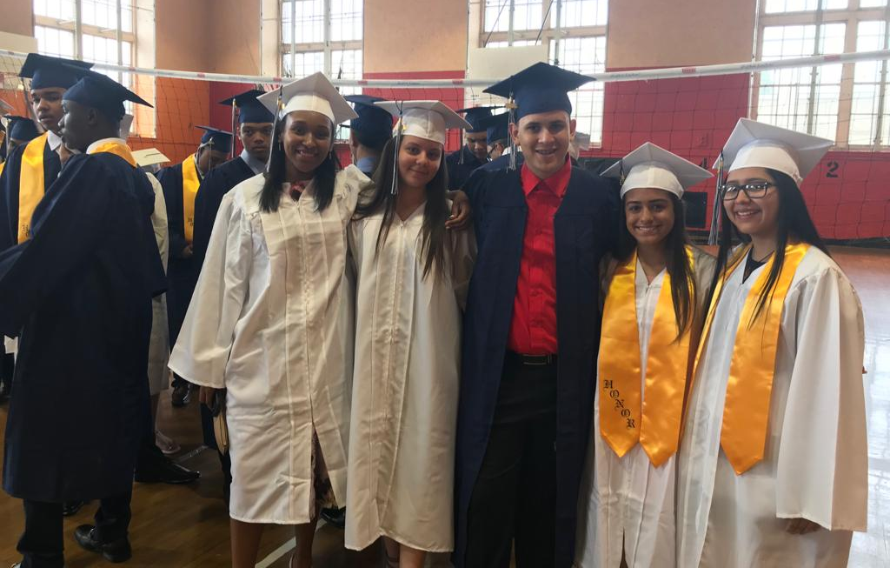

Why Should You Choose HSHCS?

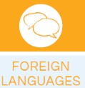
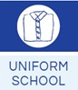
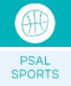
 93% Graduation Rate
 Small high school setting
 Rigorous academics with science specialties
 Certified Nursing Assistant Program
 Dual language program in Spanish
 Vast amounts of academic and extracurricular activities offered
 Technology Software Developer Program

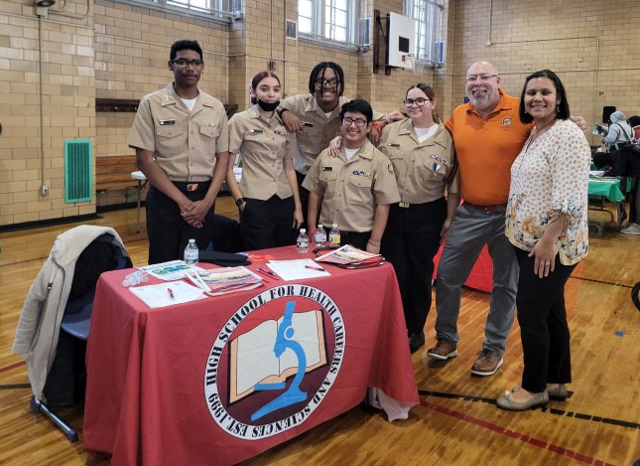

Welcome to High School for

Health Careers and Sciences

High School for Health Careers and Sciences is committed to providing students with a comprehensive multicultural education with a focus on STEAM. We offer AP courses and CTE courses. Our students are supported academically, socially and emotionally with onsite support, and community -based programs through Catholic Charities and the NY Presbyterian Health Clinic. Our afterschool programs offer a variety of extra- curricular and academic activities.

Uniform required:

HSHCS T- shirt or sweater and black pants.

PARTNERSHIPS
ACADEMIC SUPPORT




CUNY
(BMCC and City College)

Cornell University

Future Ready NYC
 New York Presbyterian
 Peer Group Connection (PGC)
 Catholic Charities
 Columbia University  
 Monroe College
 Yeshiva University
- After-school homework help and tutoring
- Saturday Regents Prep and tutoring
- The City College STEM courses
- Navy Junior Reserve
Officers Training Corps
and Drill Team (JROTC)
- Team Teaching Classes

Extracurricular Activities at HSHCS
Campus PSAL Sports:
Boy’s | Girl’s
Baseball | Softball
Basketball | Basketball
Football | Flag Football
Soccer | Soccer
Swimming | Swimming
Wrestling | Indoor, and Outdoor Track
 | Volleyball
CLUBS
Student Government
Guitar Club
Fitness Club
Cooking Club
Cheerleading Club
Diversity & Gender Alliance Club
Crochet & Knitting Club
Robotics Club
Martial Arts Club
Gaming Club
Women & Men Empowerment Club
Lunch Club
Knitting Club
Percussion Club
Yearbook Club
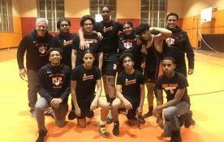

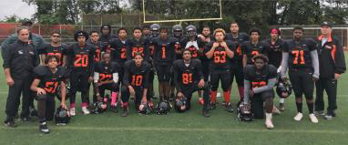

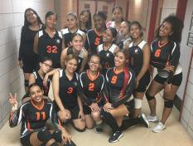
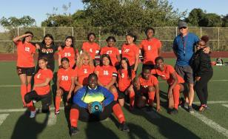

Academic Experience at HSHCS

College Now: CUNY College Now Courses in the 10th grade & onward.

AP Courses:
- Literature & Language
- Spanish Literature & Composition
- Art 2D Design
- Biology
- Environmental Science
- U.S. History“Everything seems impossible until it is done.”
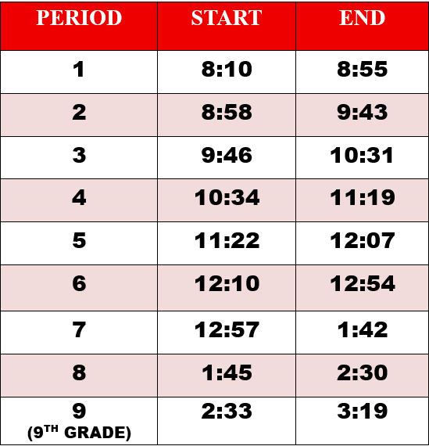
- Albert Einst
BELL SCHEDULE

